Replacing & Inserting Black Gripper Bands
Installing new Black Gripper Bands into the Support Rollers can be difficult if not before attempted.
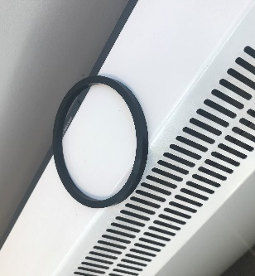
The below steps have been provided to help with the installation process.
Step 1: gently warm the Gripper Bands before trying to install them. Subjecting the Bands to a gentle heat source will make them more pliable and easier to stretch. This can be via a radiator, submerging them in warm water or blowing hot air on the bands.
Please avoid exposing the Gripper Bands to direct sunlight (UV) for more than 1 hour.

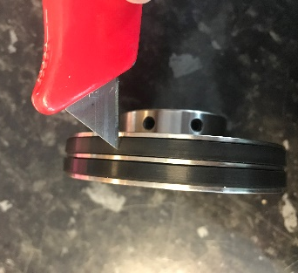
Step 2: using a sharp knife gently cut the existing Gripper Bands and remove from the Support Roller mandrels.

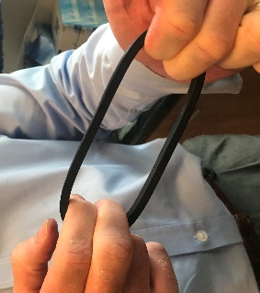
Step 3: stretch each new Gripper Band by hand before attempting to install.

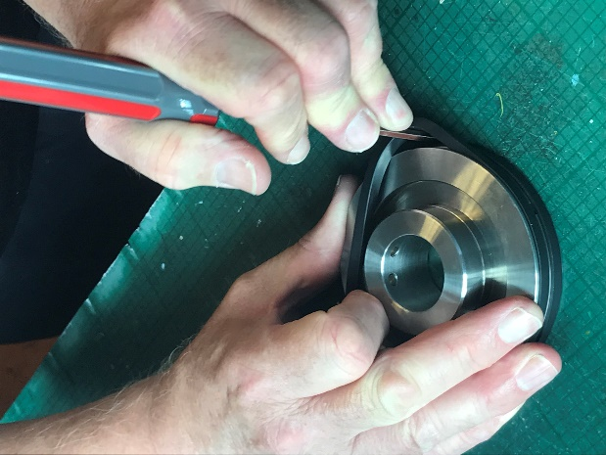
Step 4: Apply the Gripper Band into a Support Roller channel.
Using a screwdriver or some other long and thin (strong) object, place this in between the Support Roller and Gripper Band.
Holding tight the Gripper Band on one side and putting the Support Roller on a flat surface. Work the screwdriver around the circumference of the Support Roller until the Gripper Band finds its place in the channel. This may take a few attempts and be careful not to snap the Gripper Bands.
Continue this process until all Gripper Bands have been located.

